JENKINS CHALLENGES

CREATE ONE DECLARATIVE PIPELINE JOB

pipeline {
agent any

tools {
maven "MVN_HOME"
}

stages {
stage('Checkout') {
steps {
git branch: 'main',
url: 'https://github.com/pmohd6065-ux/hiring-app.git'
}
}

stage('Build') {
steps {
sh 'mvn clean install -f pom.xml'
}
}

stage('SonarQube Analysis') {
steps {
withSonarQubeEnv('SonarQube') {
sh 'mvn sonar:sonar'
}
}
}

stage('Upload to Nexus') {
steps {
script {
nexusArtifactUploader(
artifacts: [[
artifactId: 'hiring',
classifier: '',
file: "target/hiring.war",
type: 'war'
]],
credentialsId: 'nexus',
groupId: 'in.javahome',
nexusUrl: '16.16.25.136:8081',
nexusVersion: 'nexus3',
protocol: 'http',
repository: 'hiring-app',
version: "3.0-SNAPSHOT"
)
}
}
}

stage('Deploy to Tomcat') {
steps {
script {
deploy adapters: [
tomcat9(
credentialsId: 'tomcat1',
path: '',
url: 'http://56.228.15.251:8080/manager'
)
],
war: '**/target/hiring.war'
}
}
}

stage('Slack Notification') {
steps {
slackSend(
channel: '#jenkins-integration',
message: "✅ Declarative pipeline for hiring app successfully completed "
)
}
}
}
}

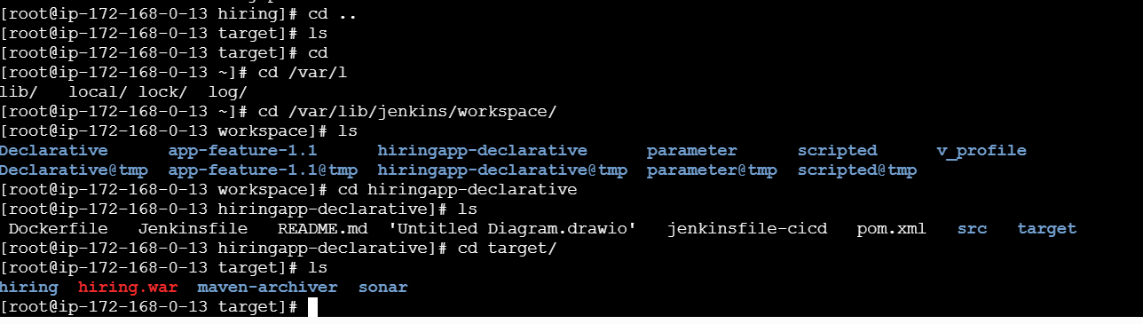
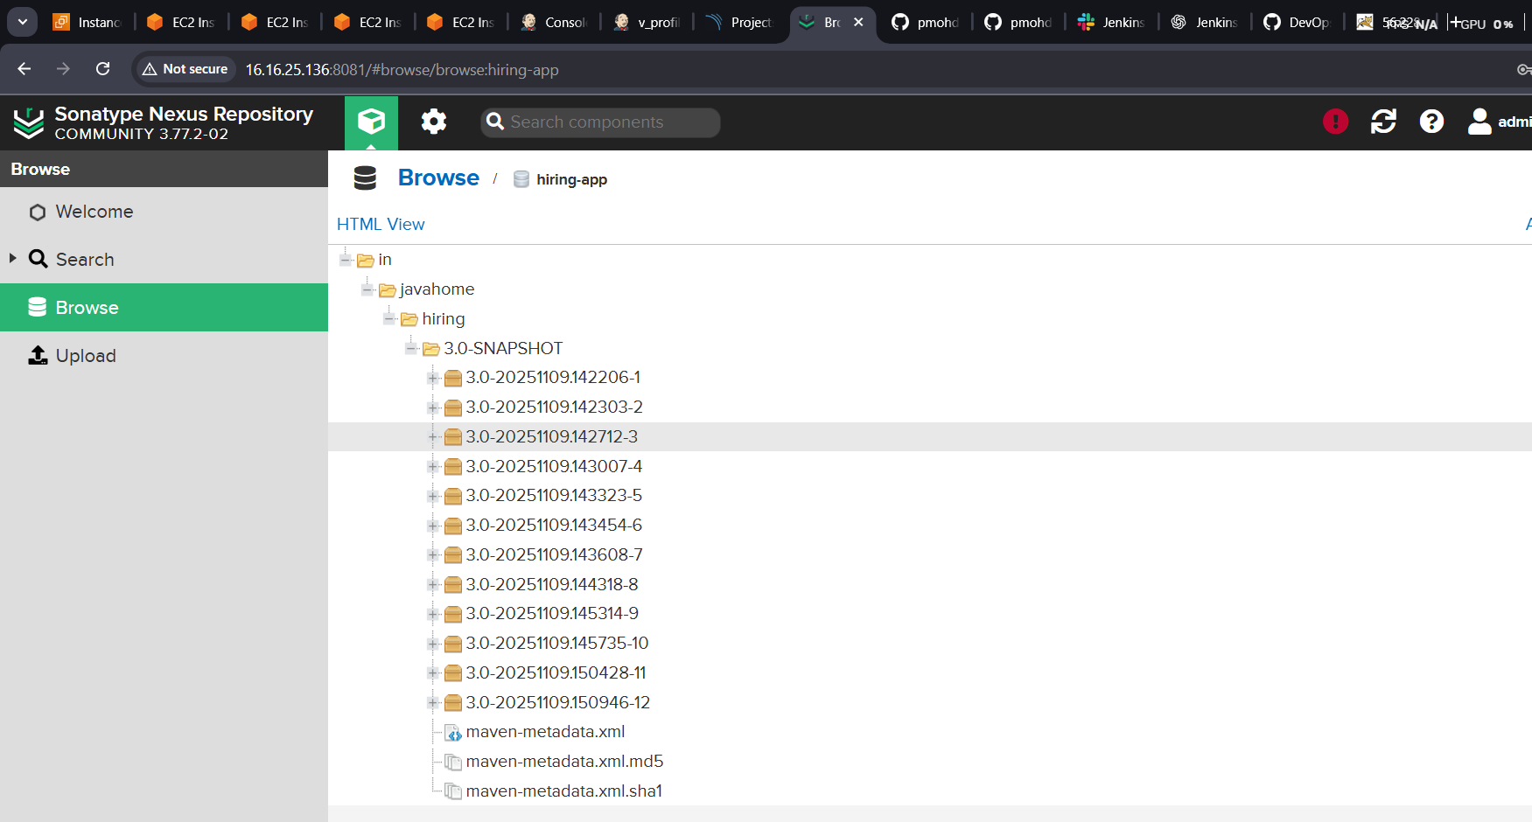

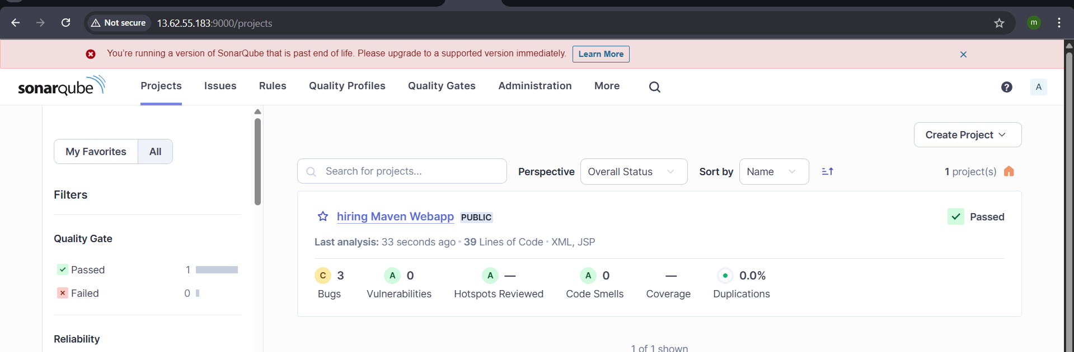

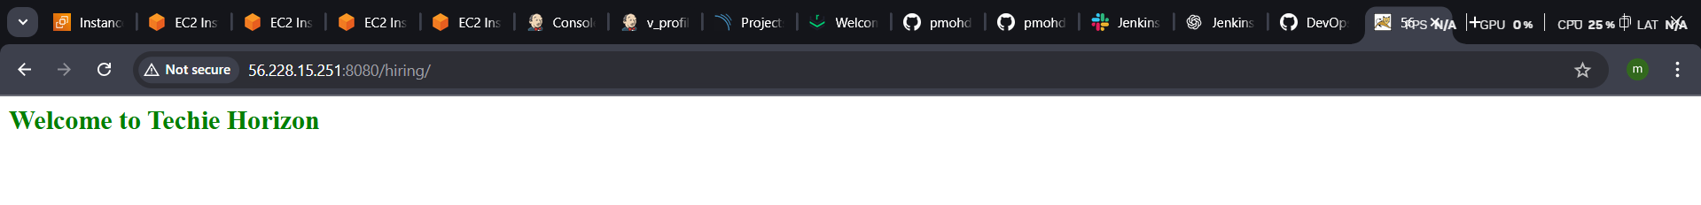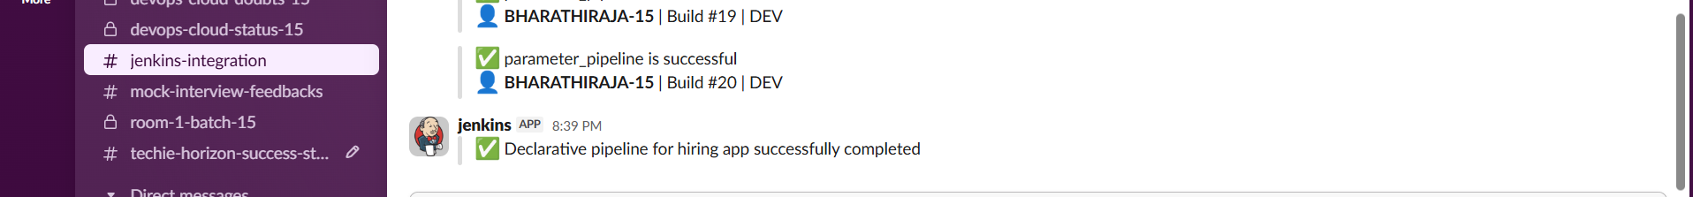
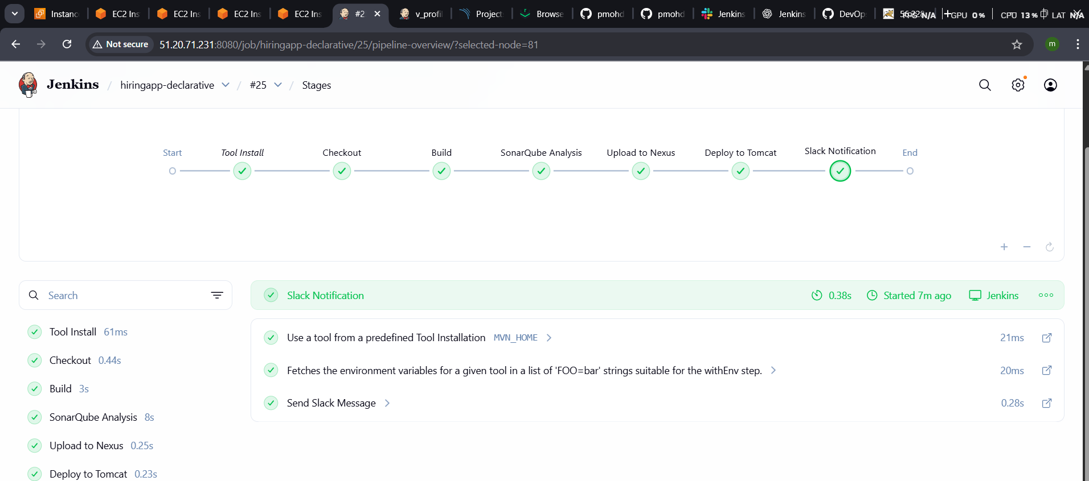

CREATE ONE SCRIPTED PIPELINE JOB
node {
// Use Maven tool configured in Jenkins
def mvnHome = tool name: 'MVN_HOME', type: 'maven'

stage('Checkout') {
git branch: 'main', url: 'https://github.com/pmohd6065-ux/hiring-app.git'
}

stage('Build') {
withEnv(["PATH+MAVEN=${mvnHome}/bin"]) {
sh 'mvn clean install -f pom.xml'
}
}

stage('SonarQube Analysis') {
withSonarQubeEnv('SonarQube') {
withEnv(["PATH+MAVEN=${mvnHome}/bin"]) {
sh 'mvn sonar:sonar'
}
}
}

stage('Upload to Nexus') {
nexusArtifactUploader(
artifacts: [[
artifactId: 'hiring',
classifier: '',
file: 'target/hiring.war',
type: 'war'
]],
credentialsId: 'nexus',
groupId: 'in.javahome',
nexusUrl: '16.16.25.136:8081',
nexusVersion: 'nexus3',
protocol: 'http',
repository: 'hiring-app',
version: '3.0-SNAPSHOT'
)
}

stage('Deploy to Tomcat') {
deploy adapters: [
tomcat9(
credentialsId: 'tomcat1',
path: '',
url: 'http://56.228.15.251:8080/manager/text'
)
],
war: '**/target/hiring.war'
}

stage('Slack Notification') {
slackSend(
channel: '#jenkins-integration',
message: '✅ Scripted pipeline for hiring app successfully completed'
)
}
}

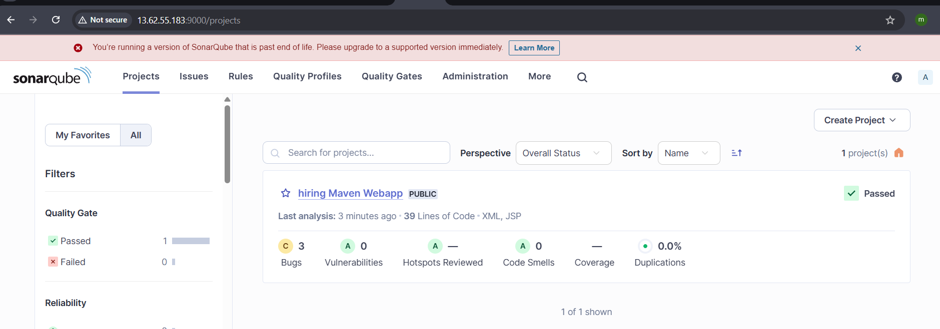

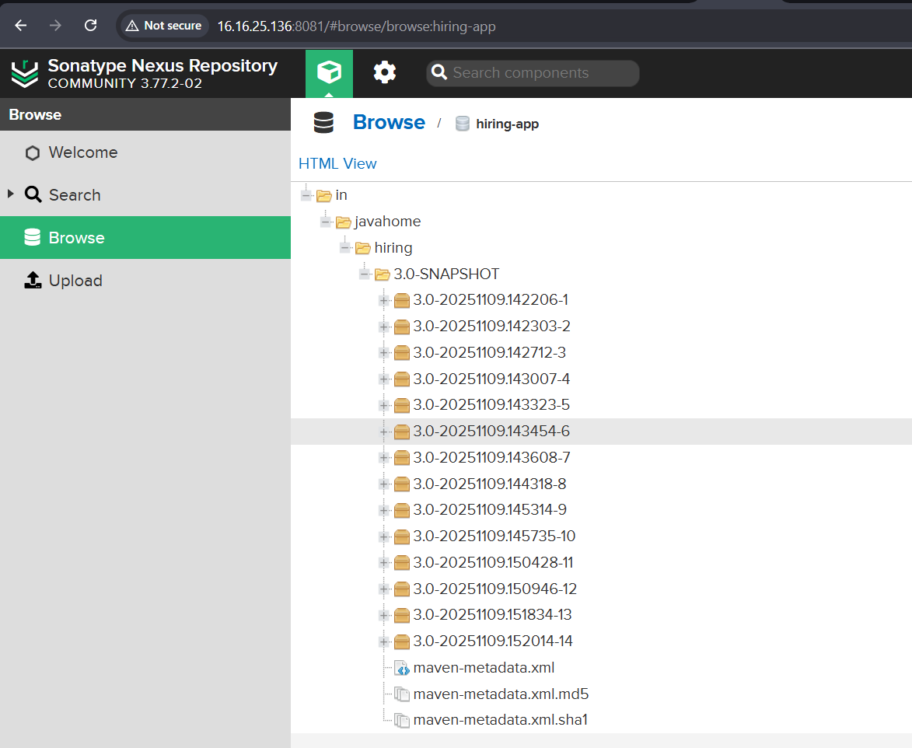

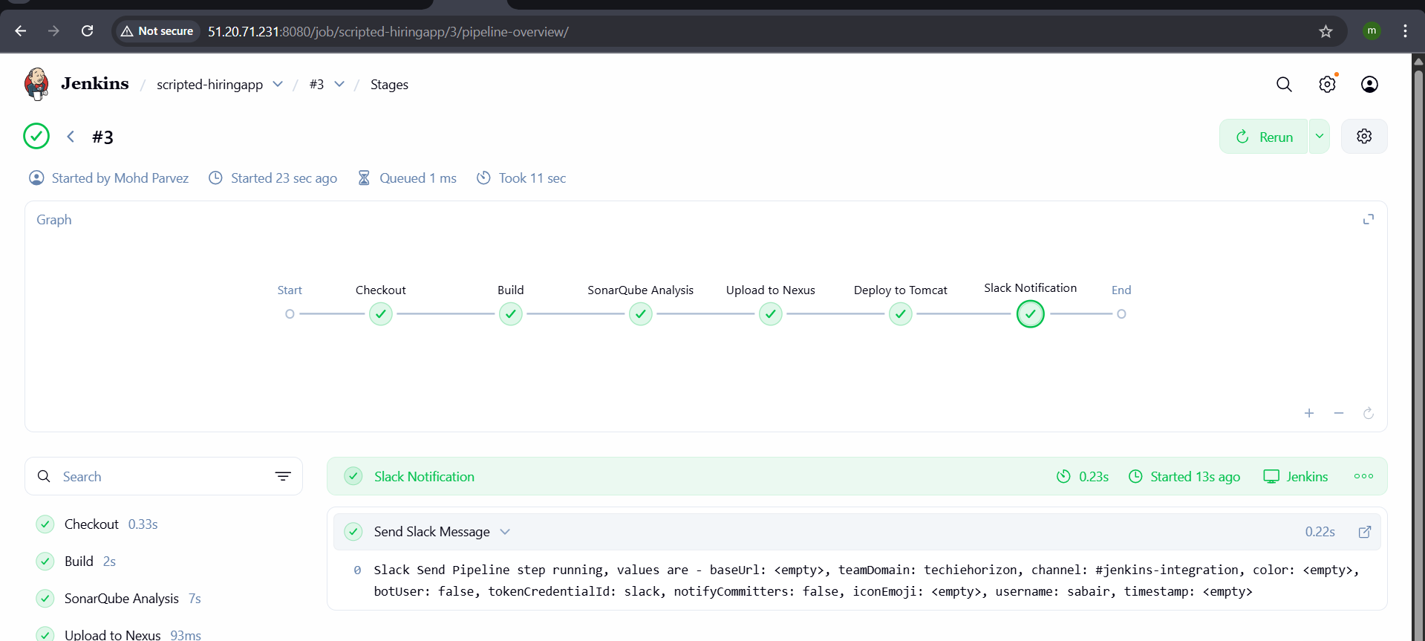
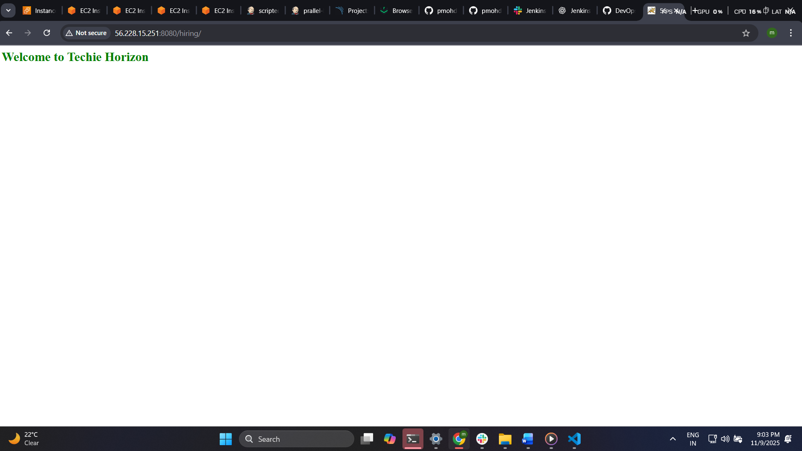

CREATE ONE MULTISTAGE PIPELINE JOB
  - Git Clone
- Create ne job seect source git paste the repo url
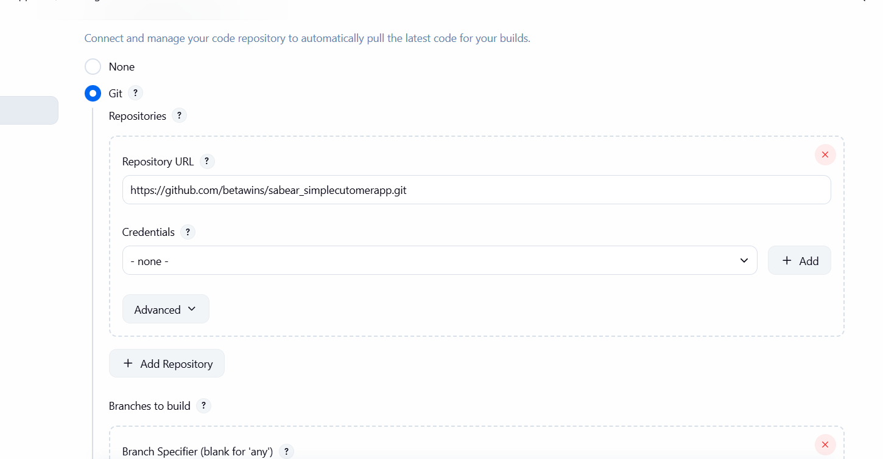
build the job it will clone the repo
note : install git in the machine also – yum install git
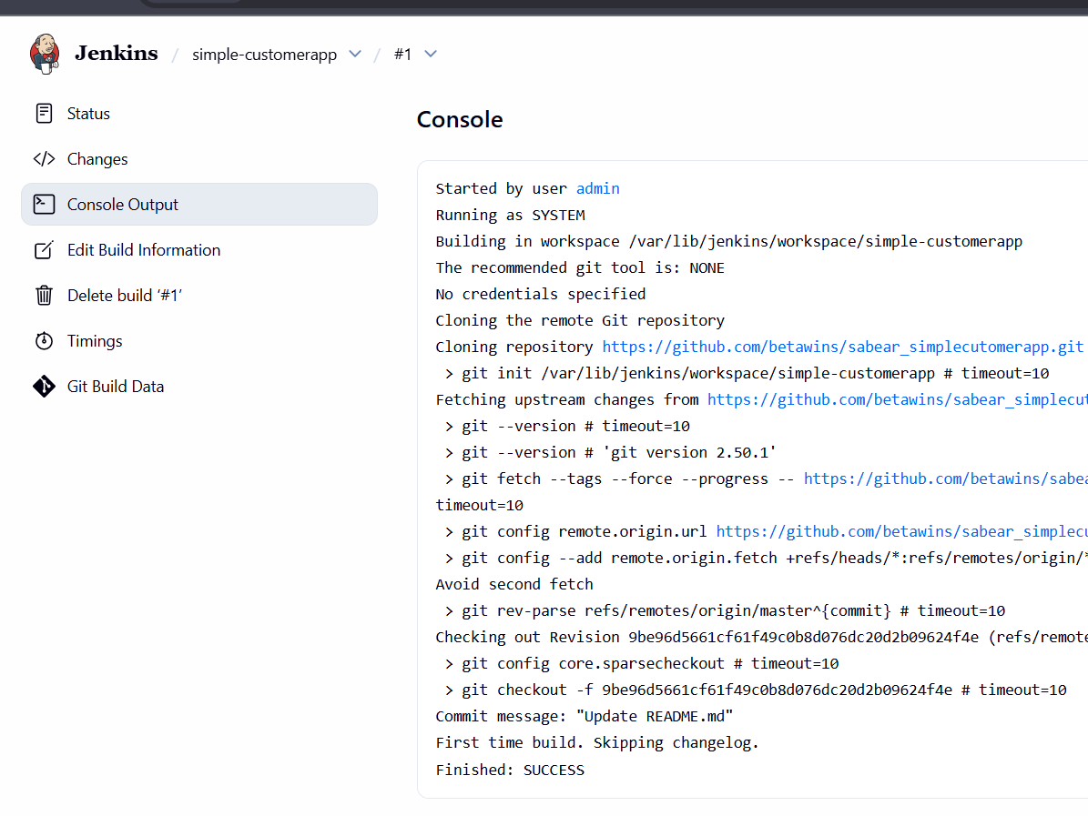

  - SonarQube Integration
lauch instance with the instance type t3.large or other large 20 gb of volume
connect to the server
yum install java-17
yum install docker
systemctl start docker
systemctl enable docker
docker pull sonarqube:10.3-community
docker run -itd -p 9000:9000 sonarqube:10.3-community
check it in the browser
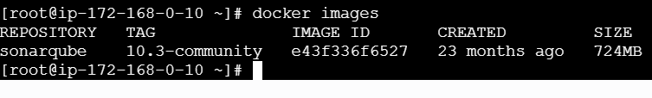
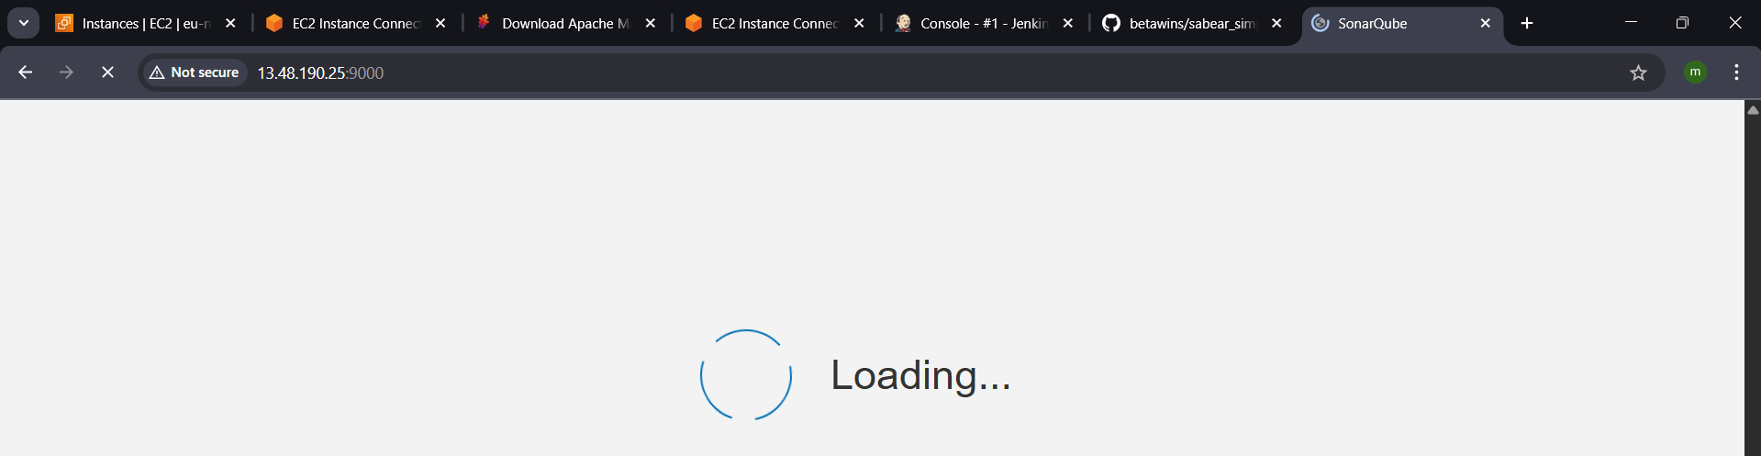
Default user : admin ; password -admin
Change the password
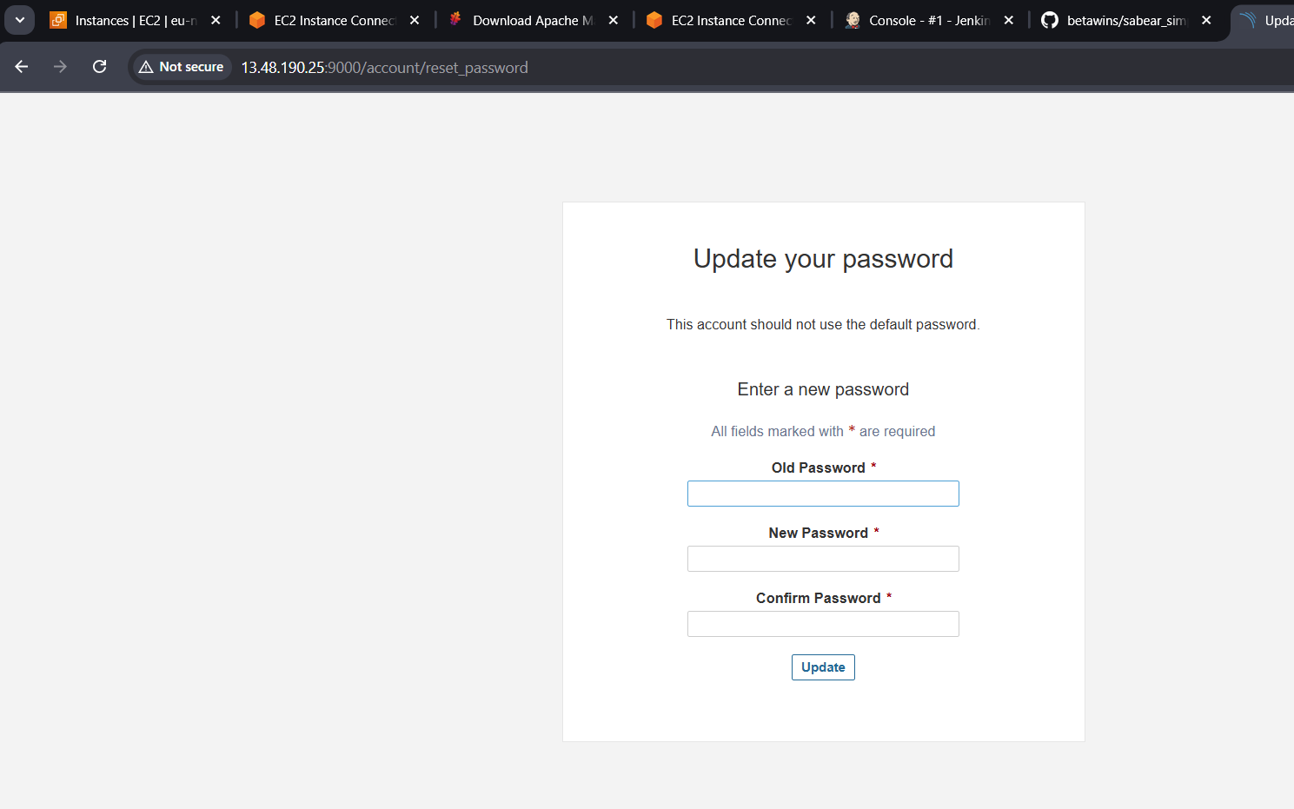
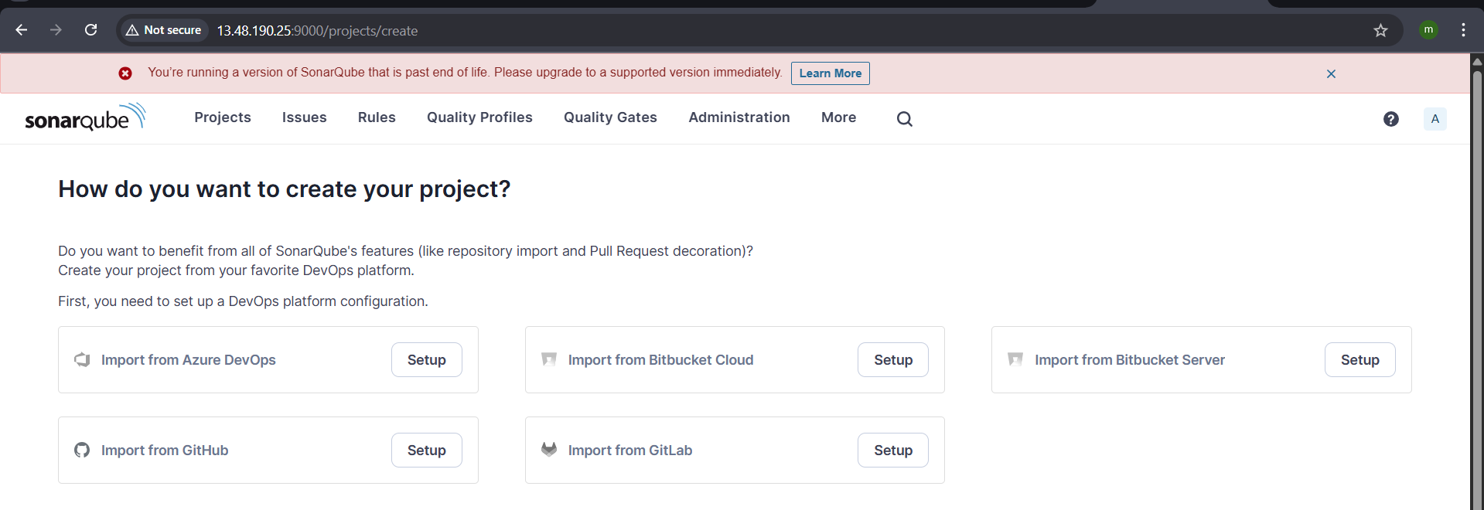
Now create token
goto myaccount generate tokencopy the secret text.
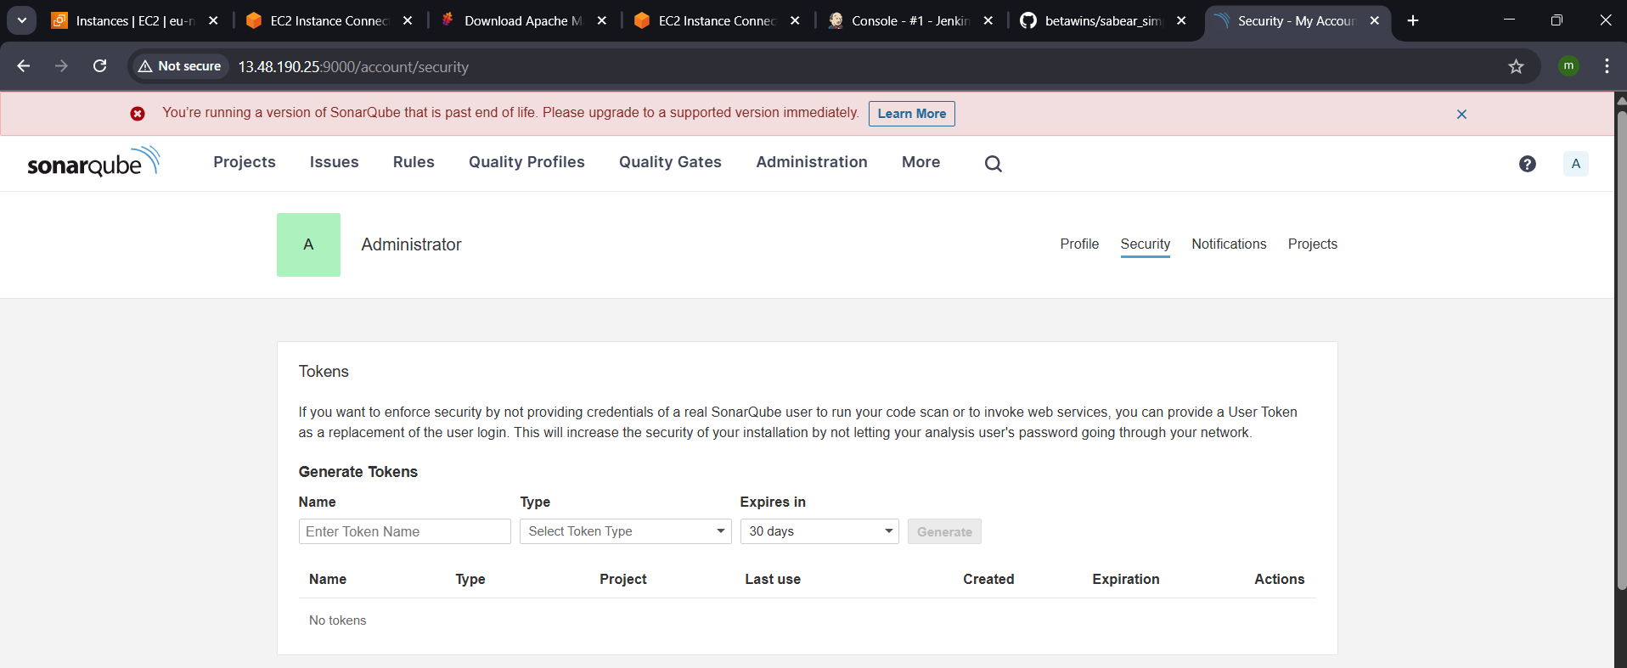
go to Jenkins—manage –system—sonarqube installation—add – secret text and url https://ipadress:9000– pate the text –save
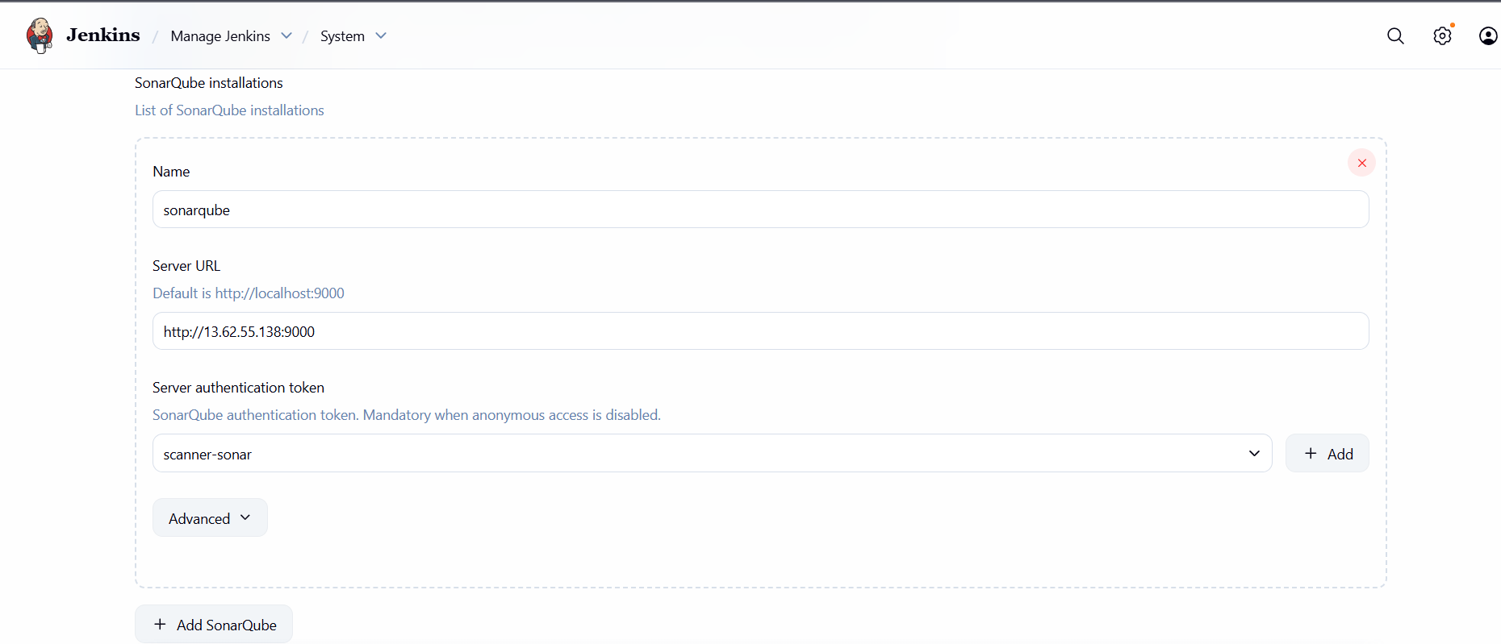
Now go to the Jenkins server
Cd /opt/
Install sonar scanner wget urlunzip fille.zip
Remane :mv sonar-scanner 6.0.0 sonar_scanner
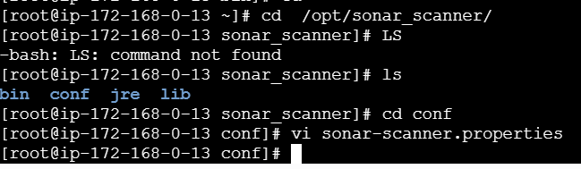
Go to cd /opt/sona_scanner/conf/
Vi sonar.properties
Add url = https:// ip sonarqube:port(9000) :wq!
Save and exit
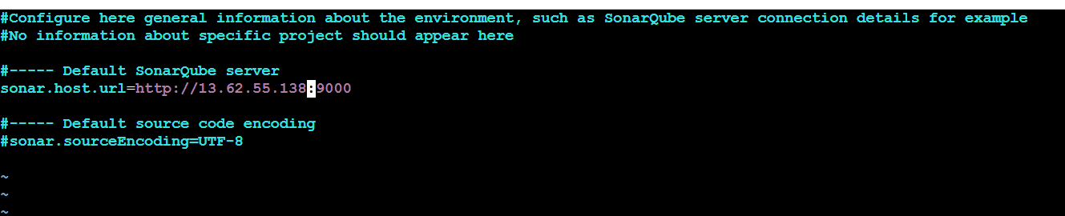
Build the job in the Jenkins
- Give the repo url add build stepsexecute sonar scanner

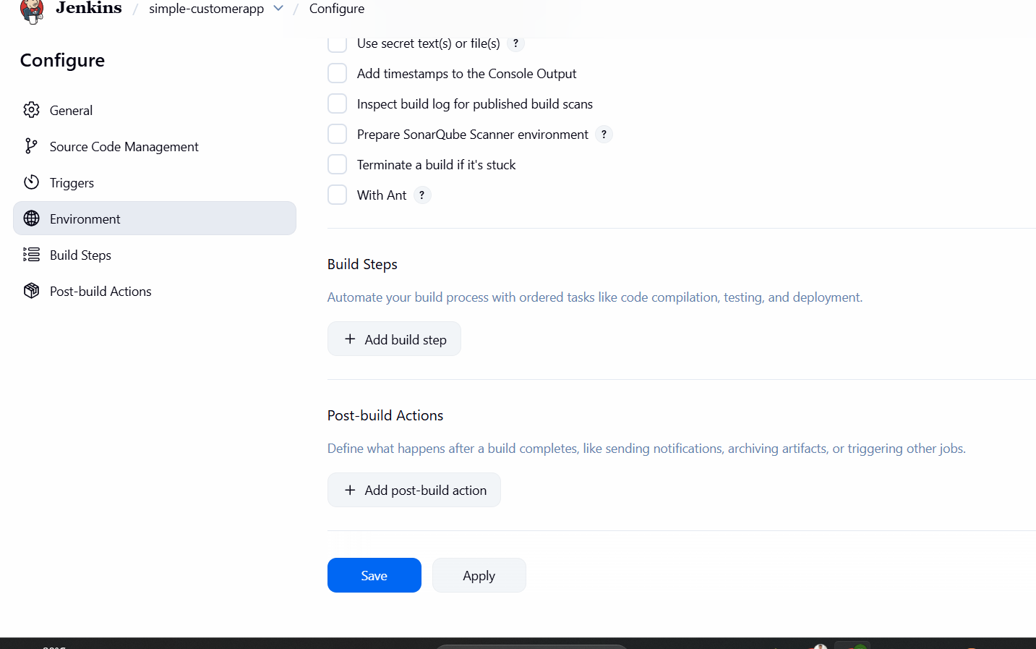
execute sonarqube sannergive analysis
sonar.projectKey=SimpleCustomerAppKey:SimpleCustomerApp
sonar.projectName=SimpleCustomerApp
sonar.projectVersion=2.0
sonar.sources = SimpleCustomerApp\\src
sonar.java.coveragePlugin=cobertura
sonar.core.codeCoveragePlugin=cobertura
sonar.junit.reportsPath=\\SimpleCustomerApp\\Reports\\BuildsUTCResults\\data
sonar.cobertura.reportPath=\\SimpleCustomerApp\\Reports\\BuildsCodeCoverage\\cobertura-xml\\coverage.xml
sonar.language=java
sonar.sourceEncoding=UTF-8
add one more build step invoke top level mavenmaven versiongoals clean install
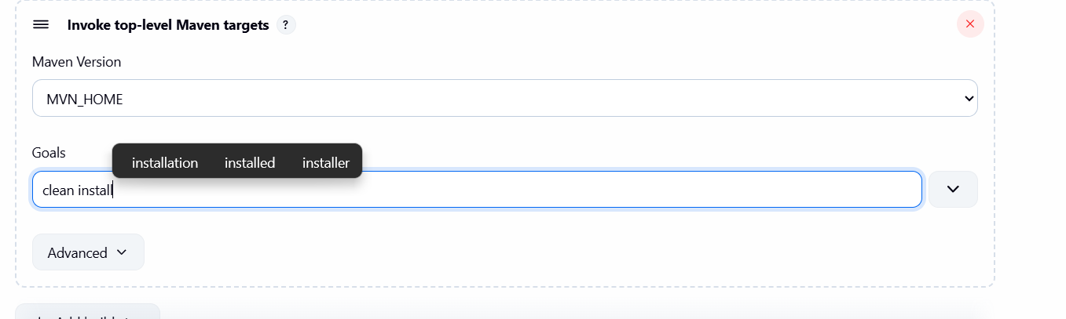
Save and build the job
Check the sonarqube
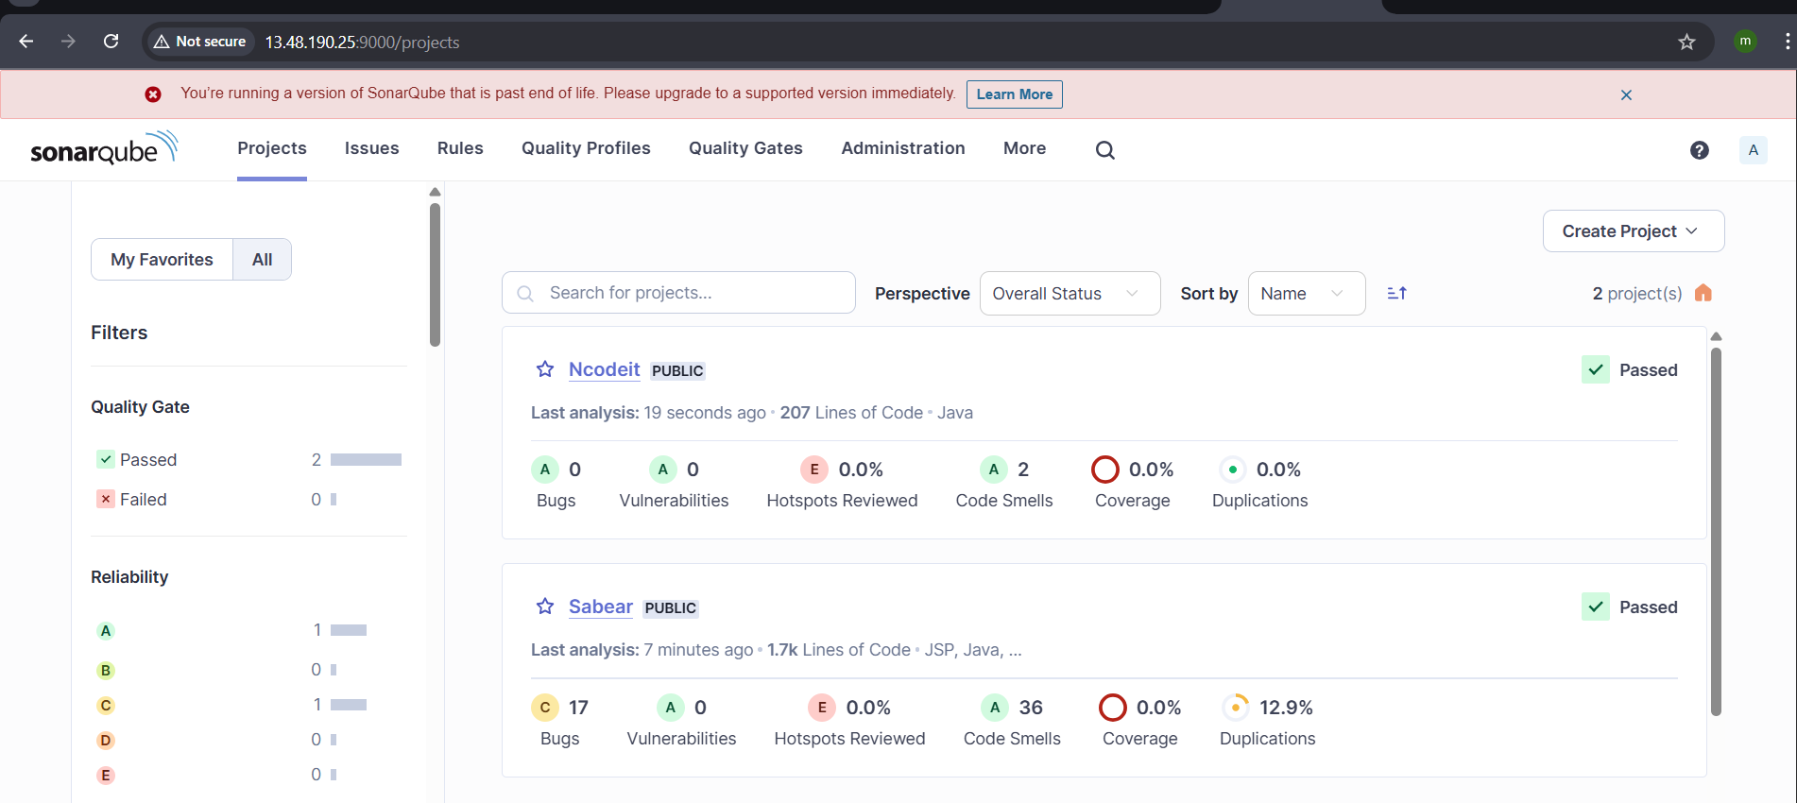

  - Maven Compilation
- Go to Jenkins server
- Cd /bin/ - change bin directory
- Go to browser : https://maven.apache.org/download.cgi
- Copy the download file link
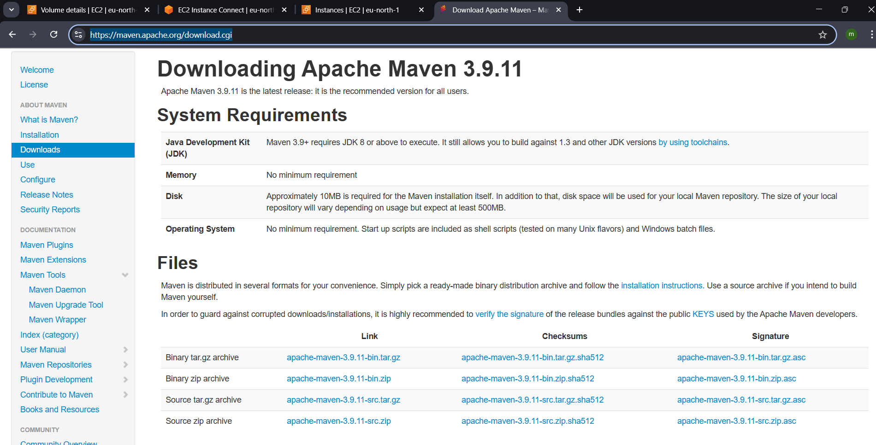
- now go to the Jenkins server
- login and got to bin directory : cd /bin/
- command to download the maven :
wget https://dlcdn.apache.org/maven/maven-3/3.9.11/binaries/apache-maven-3.9.11-bin.tar.gz

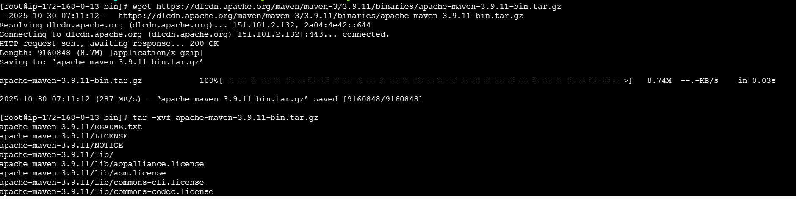
Extract : tar -xvf <file_name>

Cd apache-maven-3.9.11/bin/
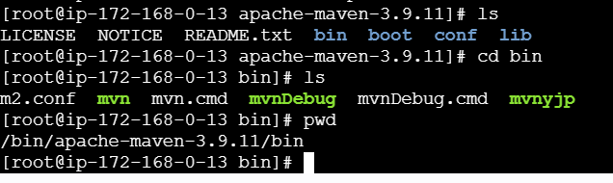
Pass the global variable to maven
Go to home directory

Vi .bash_profile # .bash_profile

# Get the aliases and functions
if [ -f ~/.bashrc ]; then
. ~/.bashrc
fi

# Set Maven environment
export MVN_HOME=/opt/apache-maven-3.9.11/bin
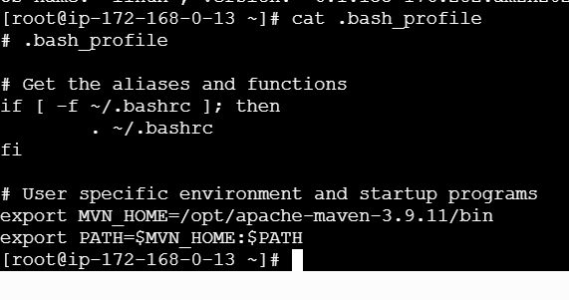
export PATH=$MVN_HOME:$PATH
- now go to Jenkins mangetoolsfind maven installations

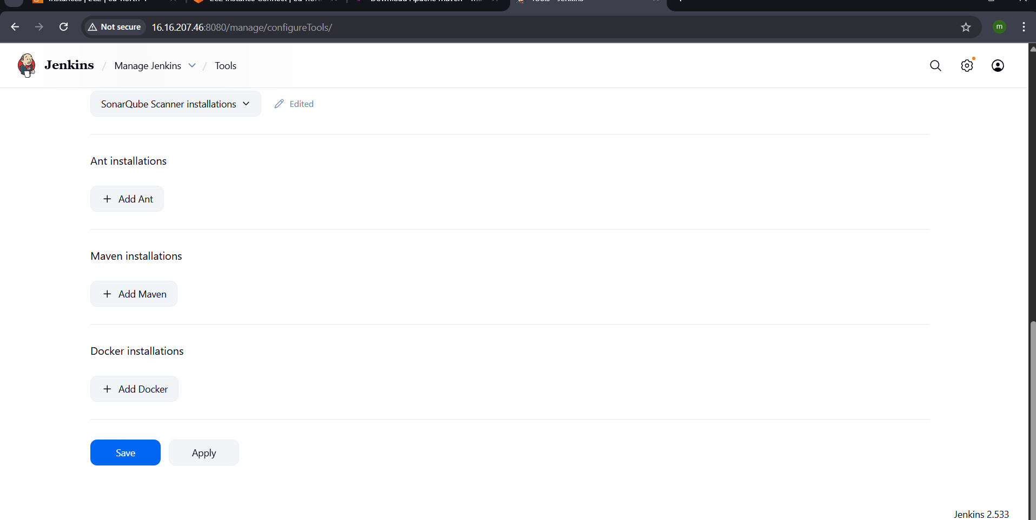
now run : source ~/.bash_profile
check :echo $MVN_HOME -shows the path
check :mvn –version
it shows the maven version
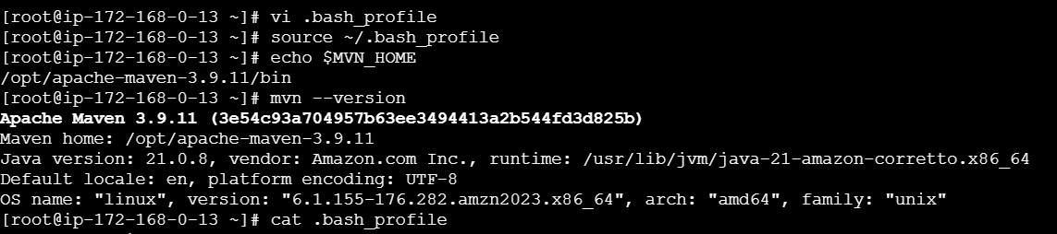
Go to Jenkins—job : simpleconfigure add build triggerinvoke mavenmavenversiongoals :clean installsave and build the job.
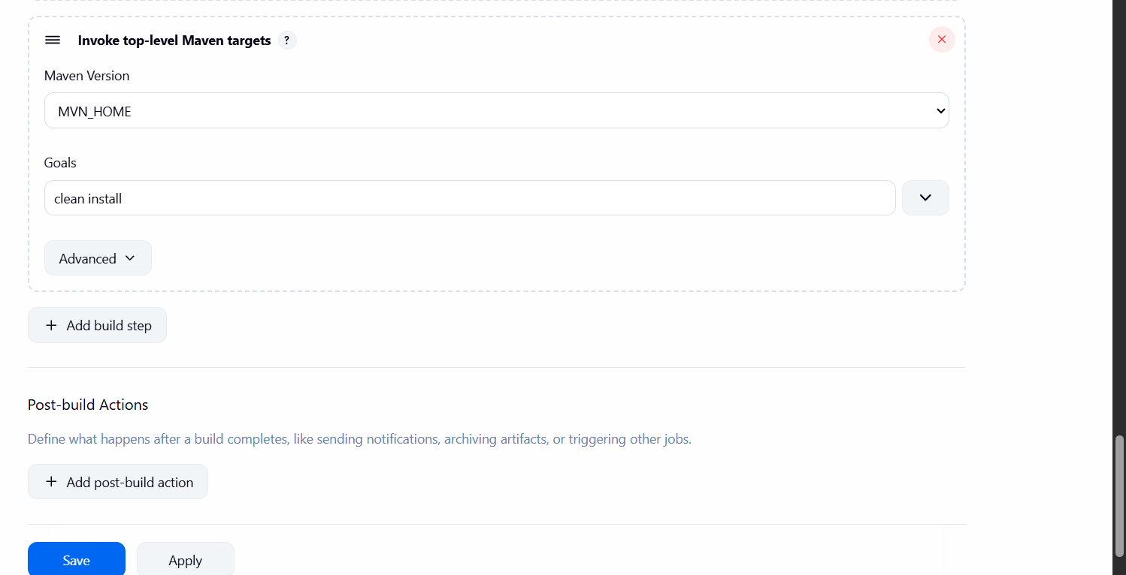
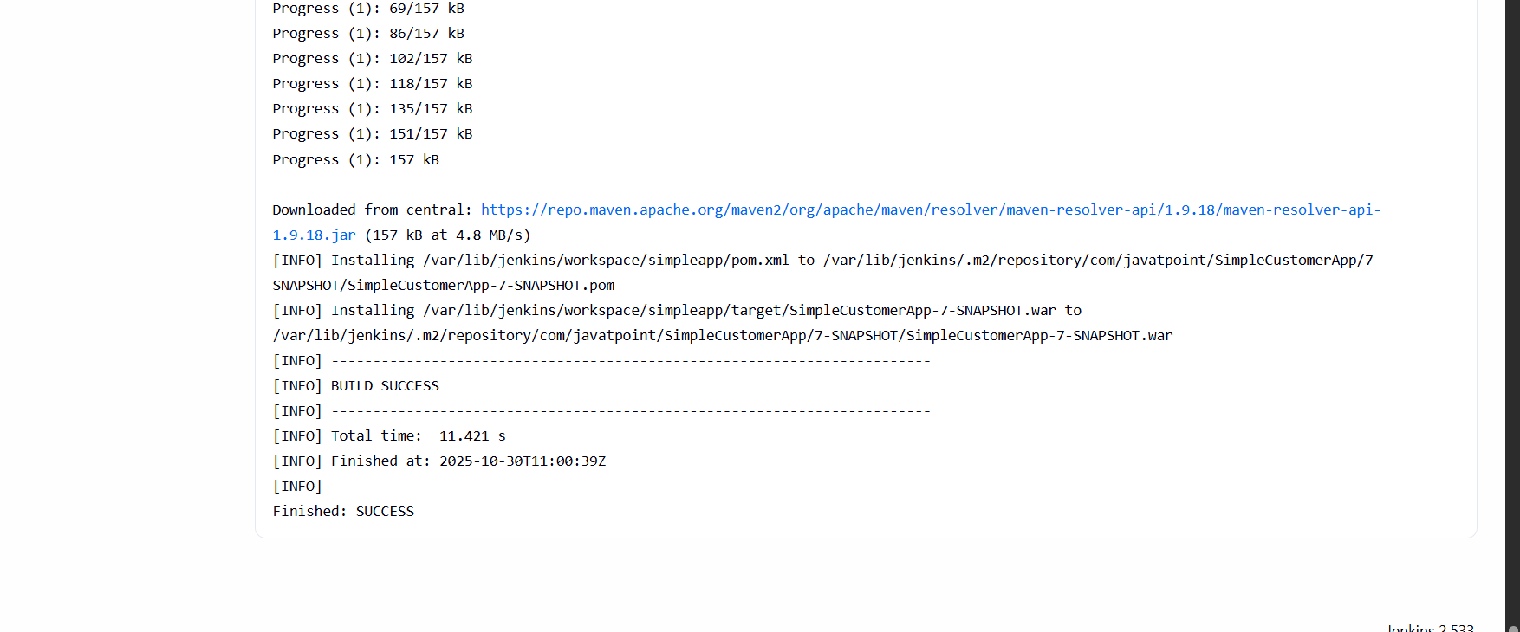
Job is completed successfully.
  - Nexus Artifactory
Lauch the instance for the nexus server
With t3.micro instance type
Nexus dependencies is only java
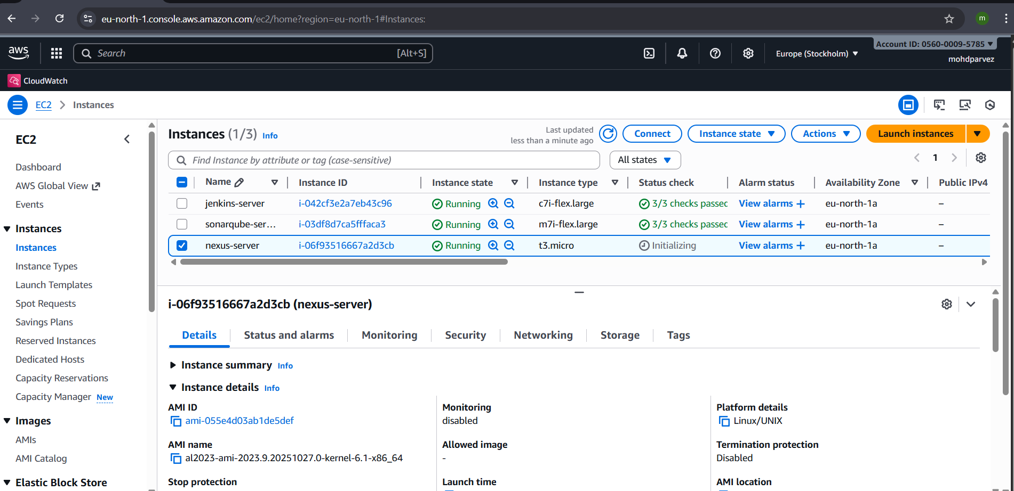
Connnect to the instance
Install java: yum install java-1.8*
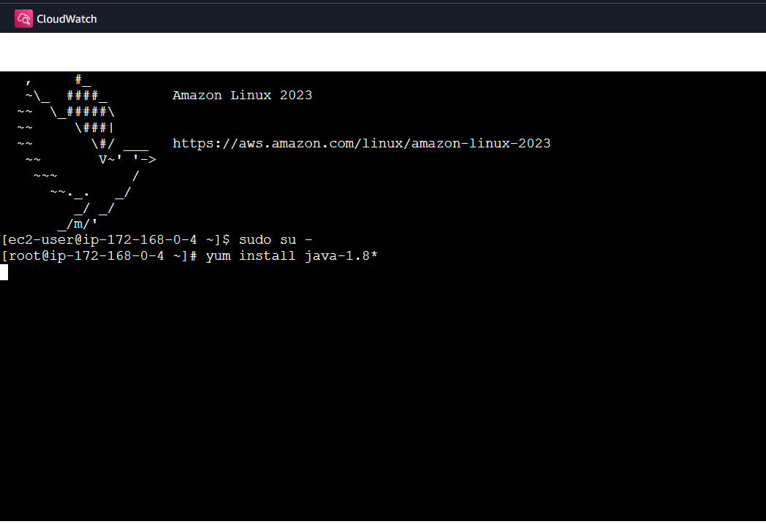
# Download Nexus
wget https://download.sonatype.com/nexus/3/nexus-3.77.2-02-unix.tar.gz

sudo tar -xvzf nexus-3.77.2-02-unix.tar.gz
mv /opt/ nexus-3.77.2-02 /opt/nexus
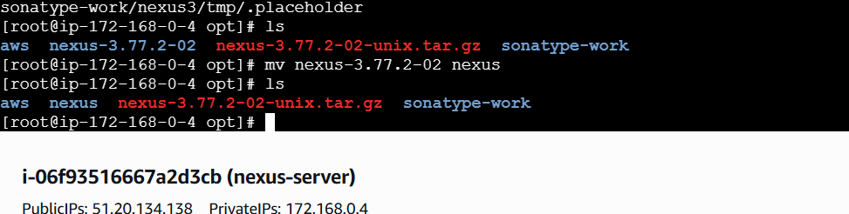
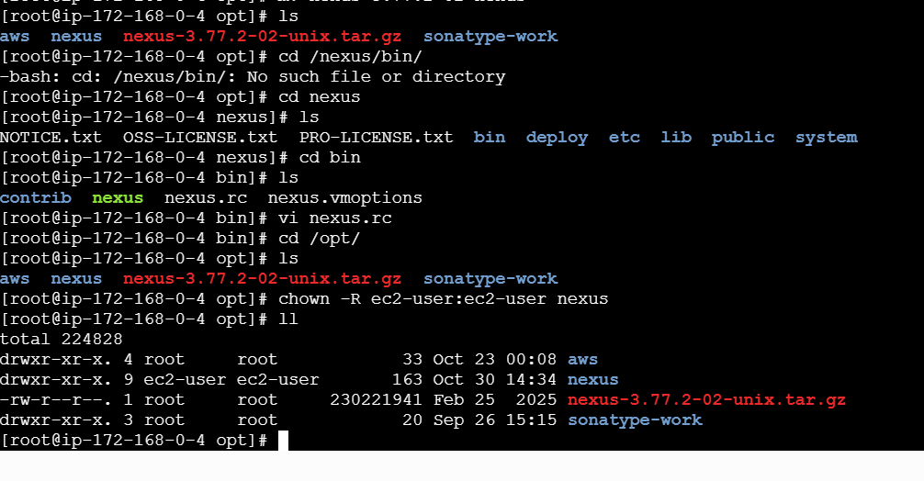
Cd /opt/nexus/bin/
Vi nexus.rc run_user_as=”nexus”:wq!
Chown -R nexus /opt/nexus

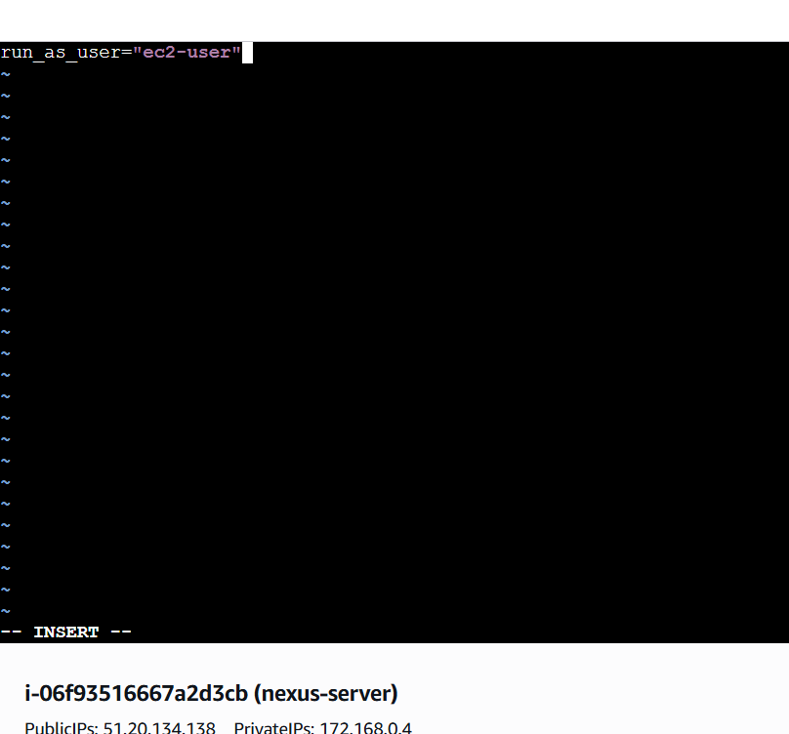
Cd /opt/nexus/bin/
./nexus start : START THE NEXUS
CHECK ON BROWSER WITH : <IPADRESS>:8081
ENABLE PORT IN SECURITY GROUPS :8081
sudo mkdir -p /opt/sonatype-work/nexus3/log
sudo chown -R nexus:nexus /opt/nexus /opt/sonatype-work
sudo chmod -R 755 /opt/nexus /opt/sonatype-work

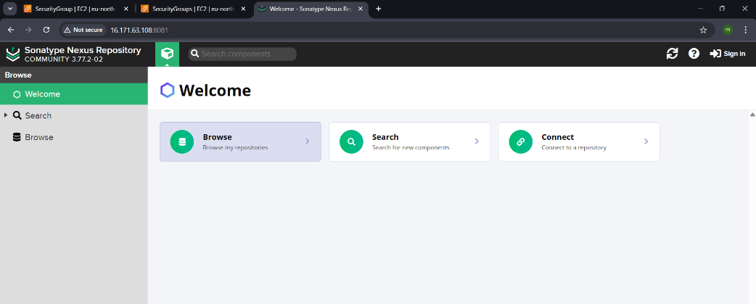
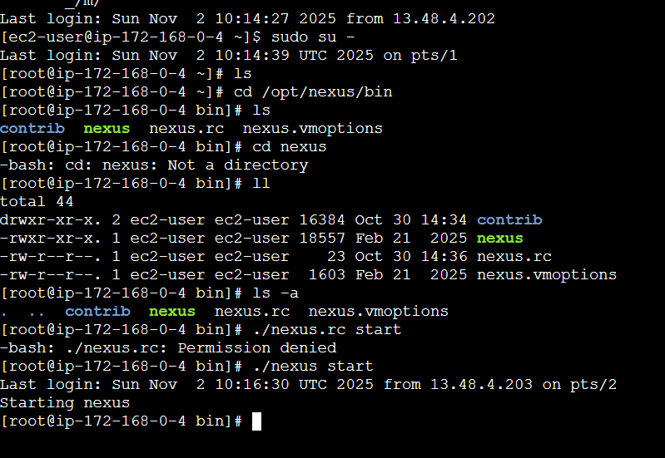
- Download nexus artifact uploader plugin
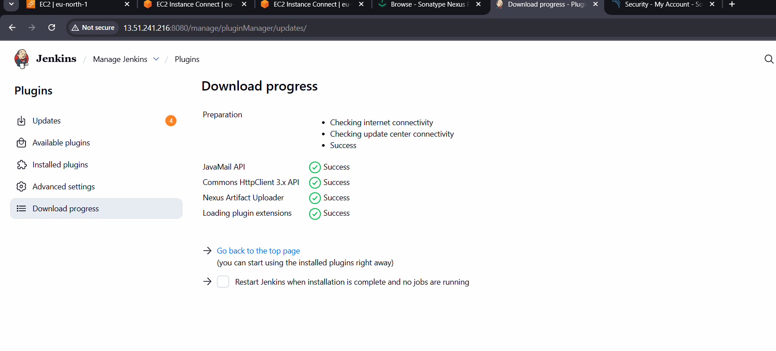
Go to nexussettingscreate repositoryselect maven 2hosted
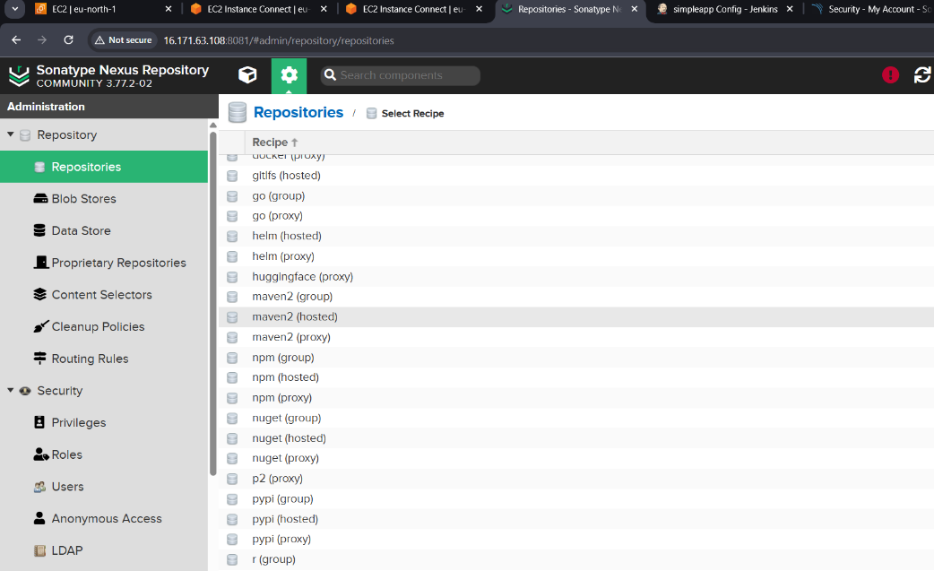
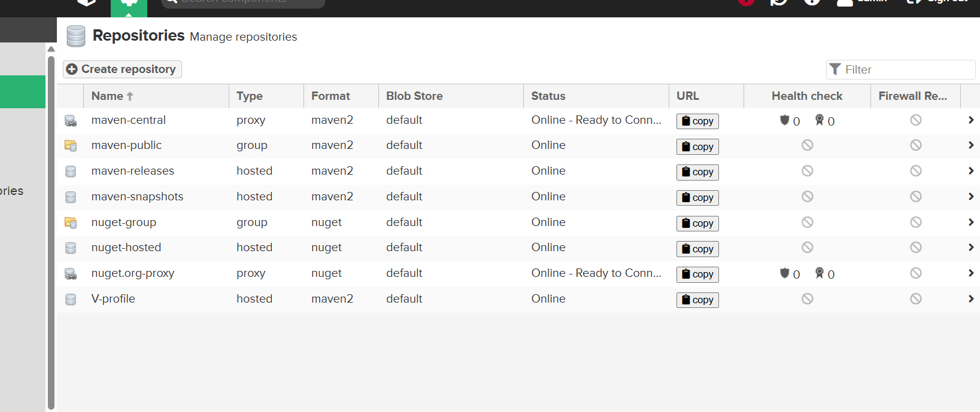
Build the job and check in the nexus server
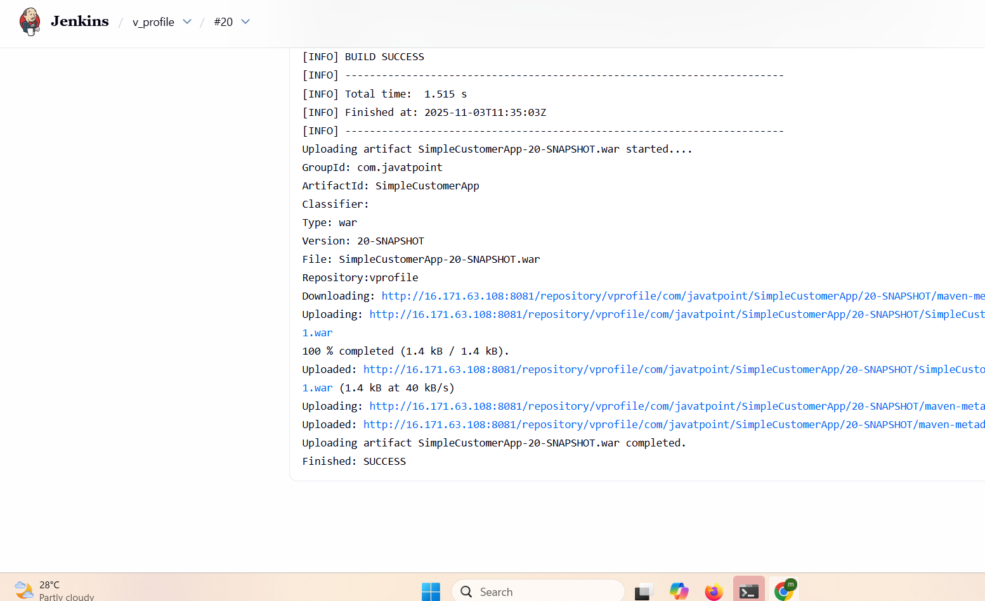

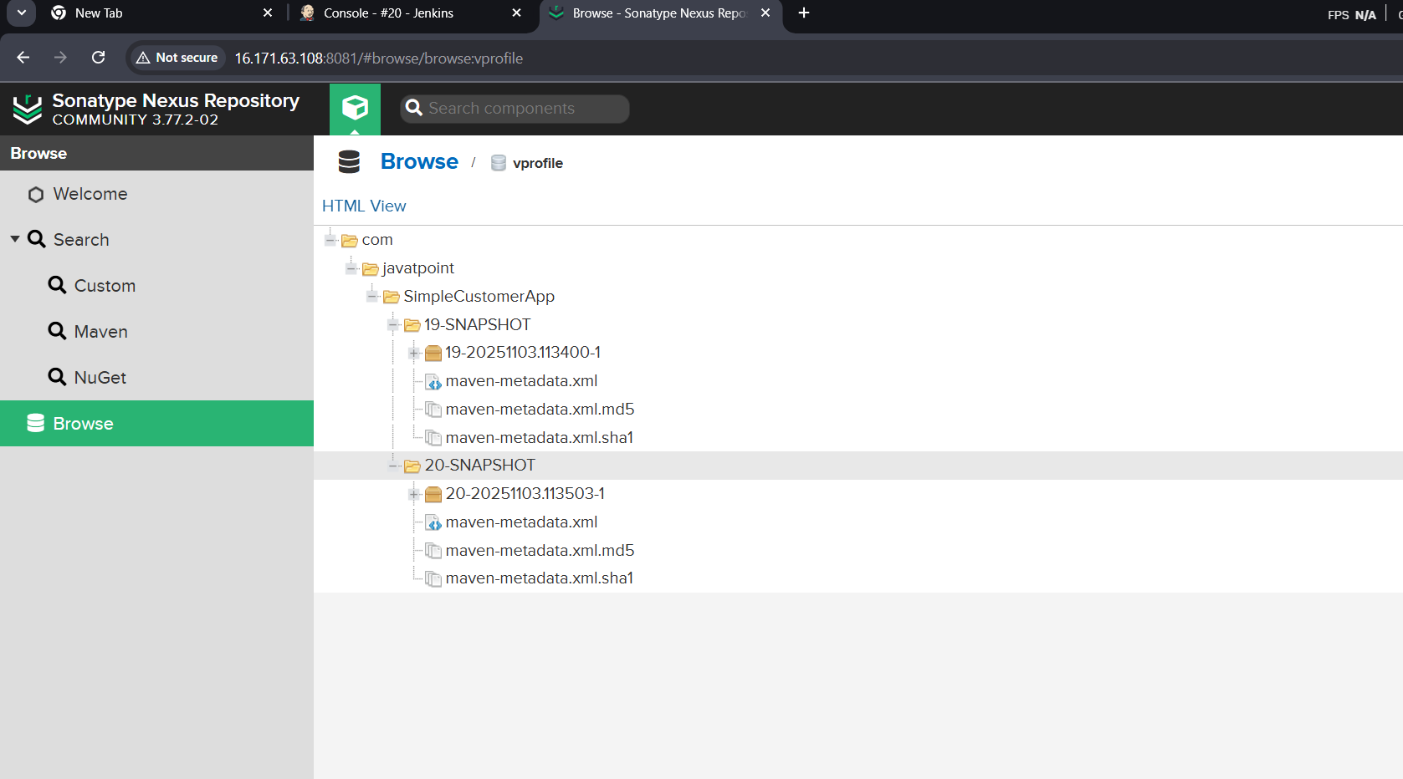

  - Slack Notification
Go to slackmoreappsjenkins Ciopen
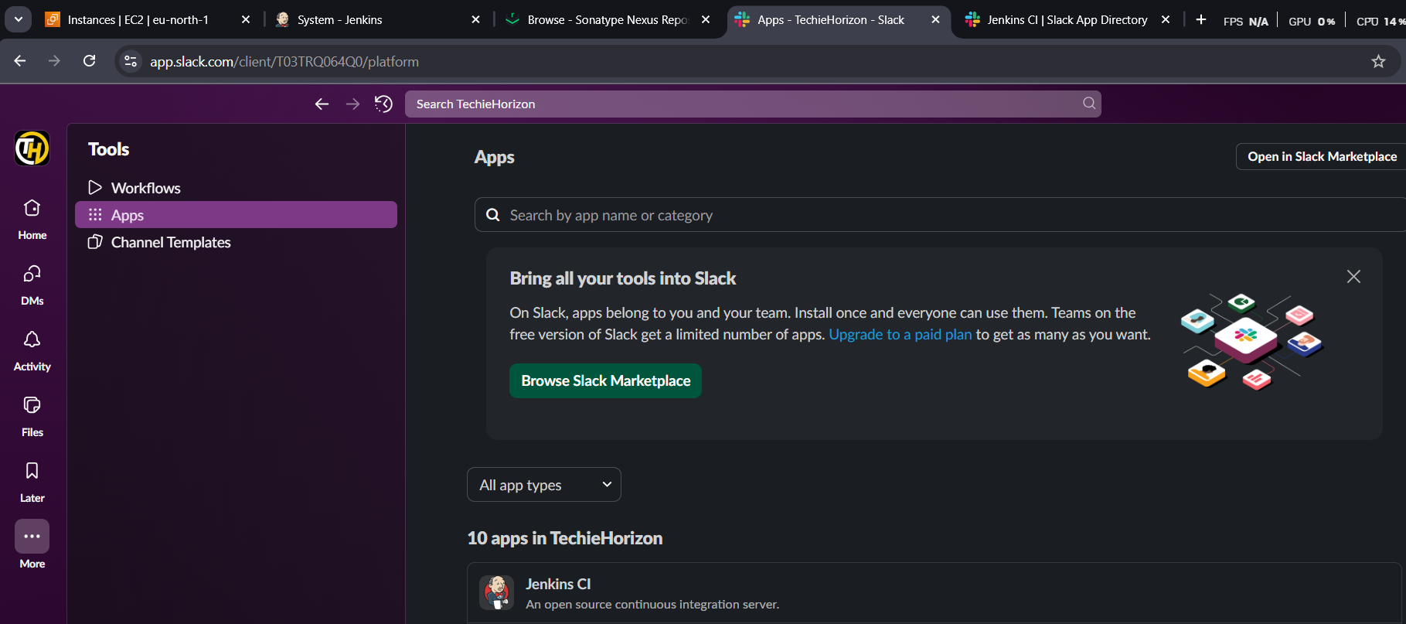
openconfigadd to slackselect channelfollow the steps addthe secret text and workspace as shown in jenkins
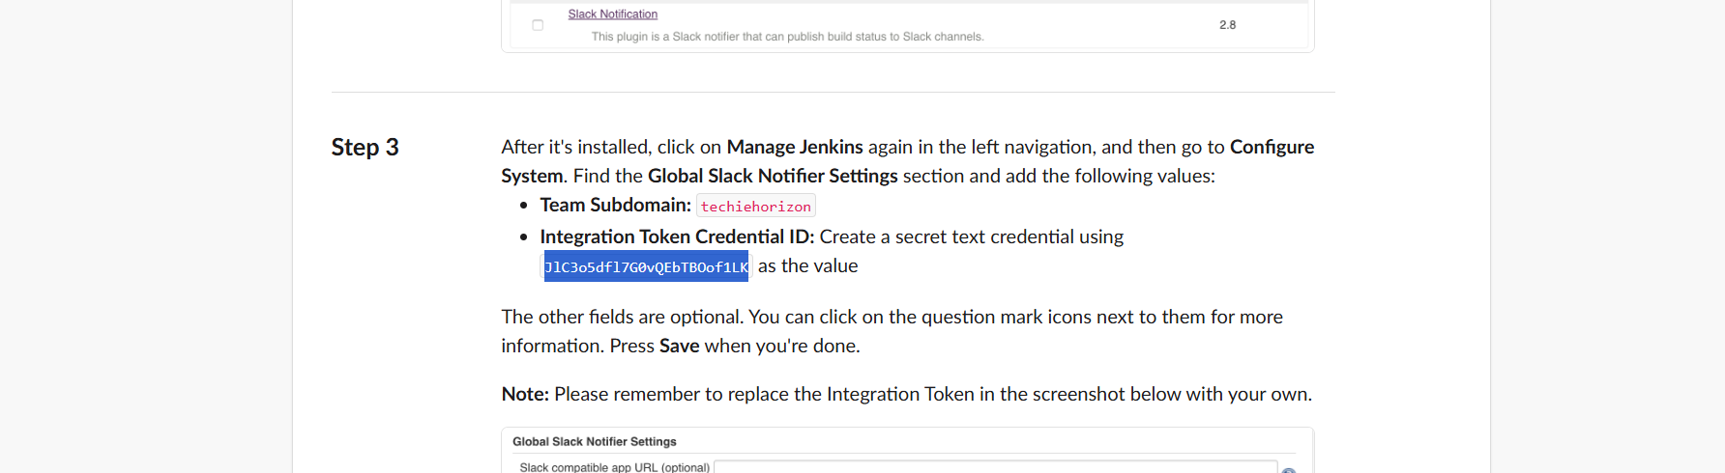
add to Jenkins and test connection
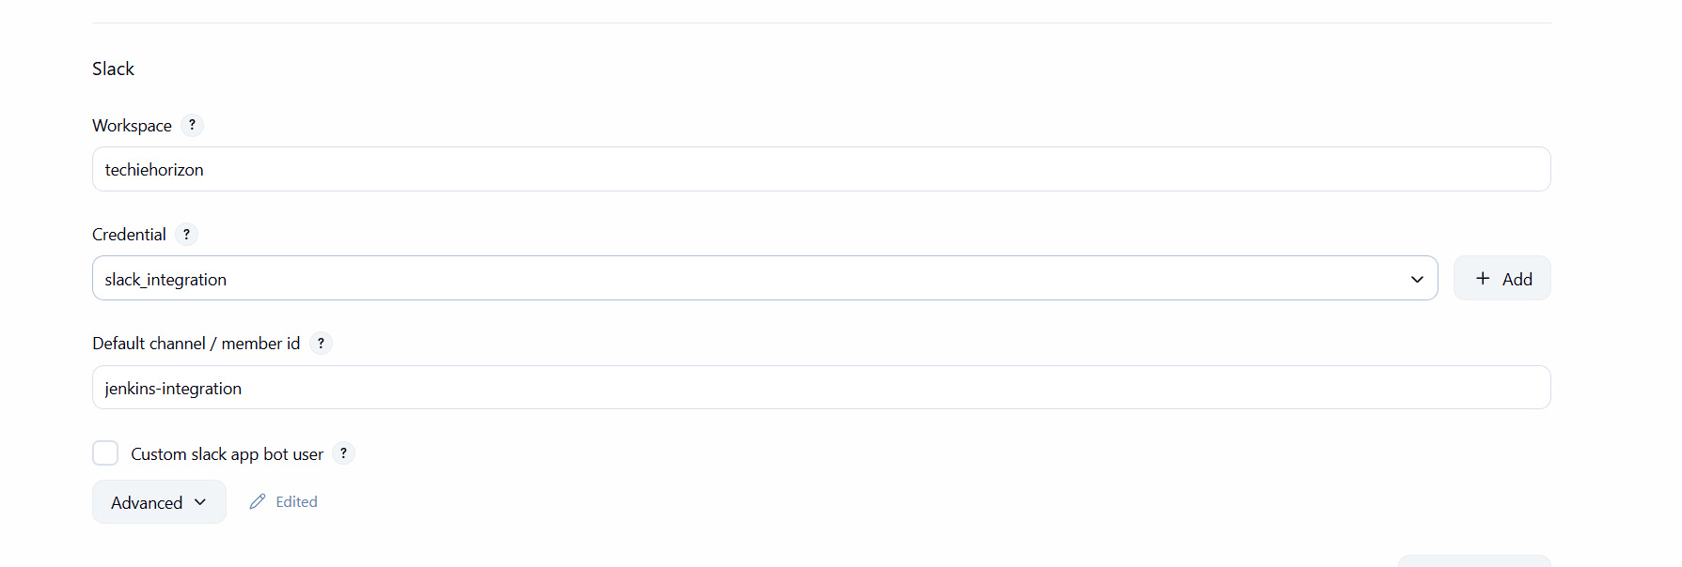
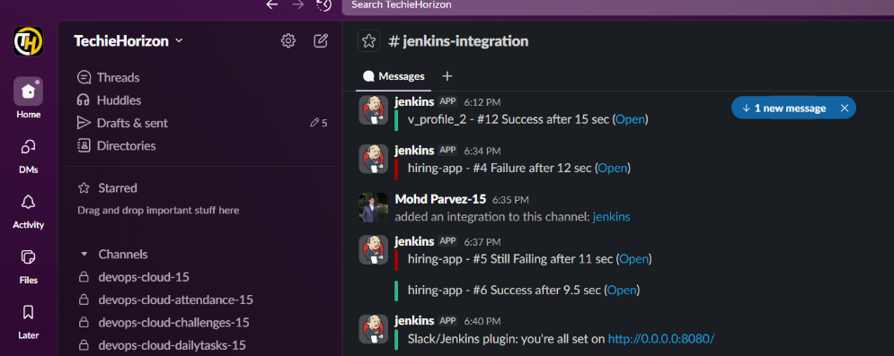
  - Deploy On tomcat
get the link to download on browser copy the link
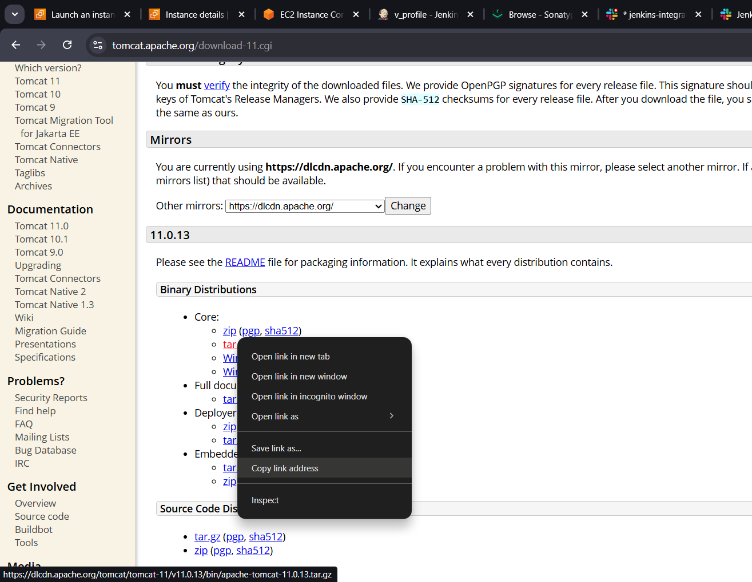
Launch instance for tomcat server t3.micro
Install java : yum install java-17
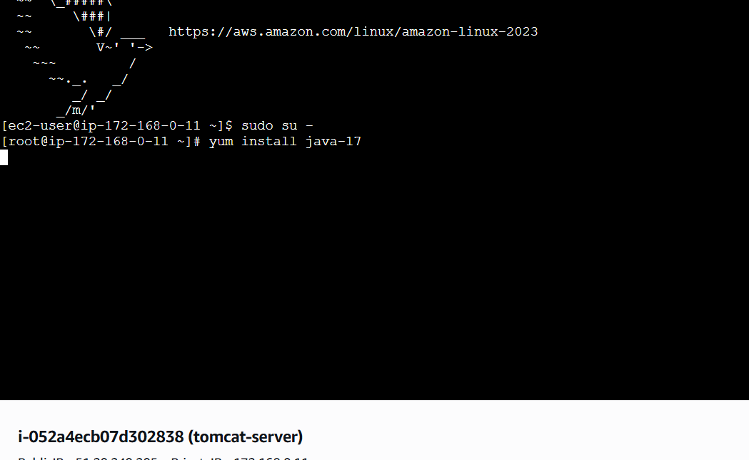
Download tomcat
Wget https://dlcdn.apache.org/tomcat/tomcat-9/v9.0.111/bin/apache-tomcat-9.0.111.tar.gz
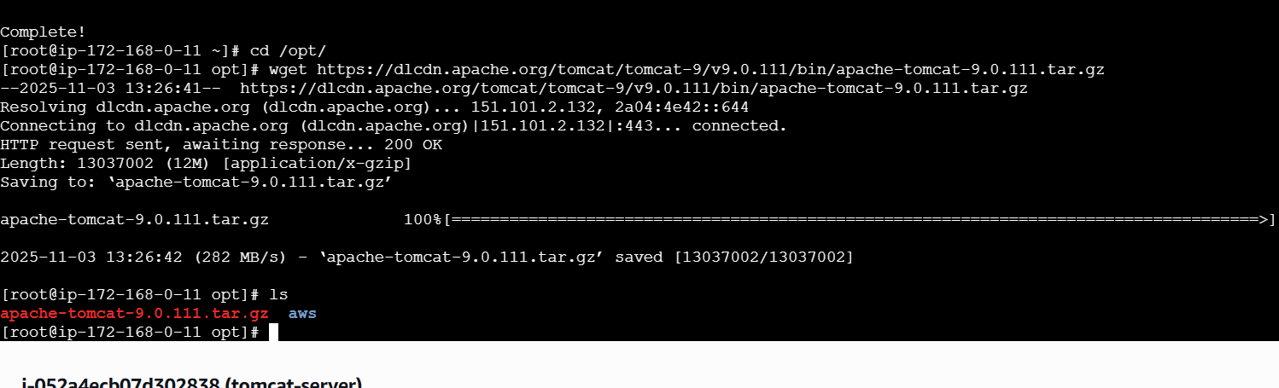
Exract the downloaded file : tar xvf “filename”
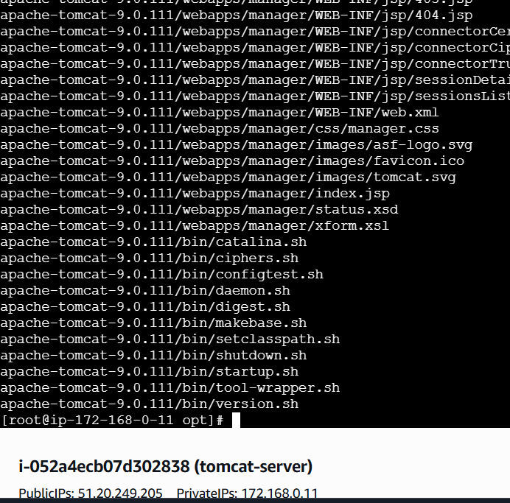
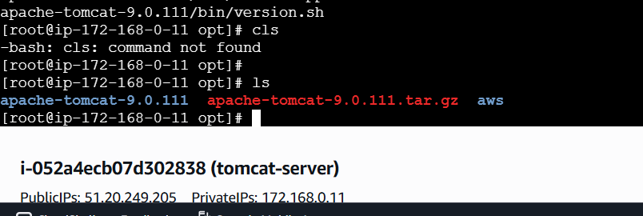
Go to bin directory
Cd /opt/tomcat_09/bin/
./startup.sh : to start the tomcat

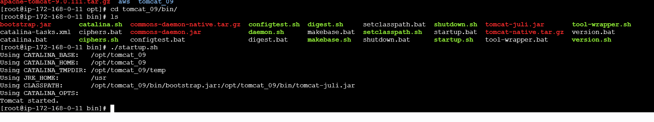
Check on the browser: <ipadress>:8080
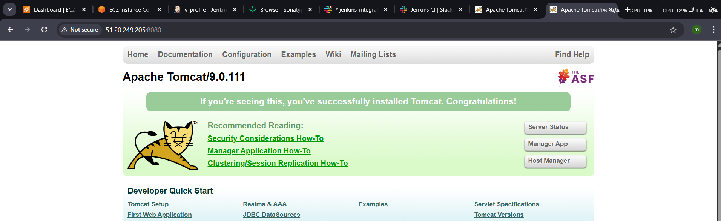
Install plug in in Jenkins : deploy to container plugin
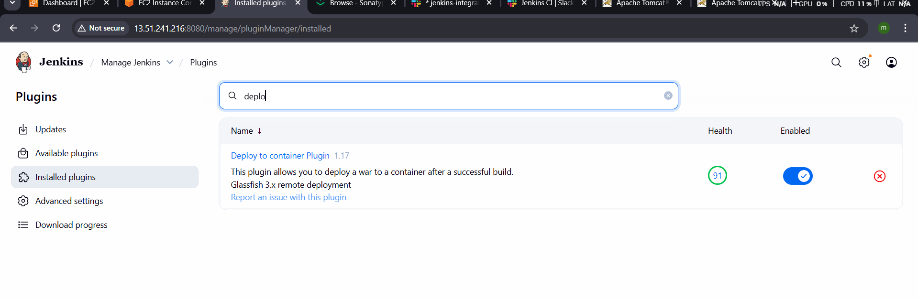

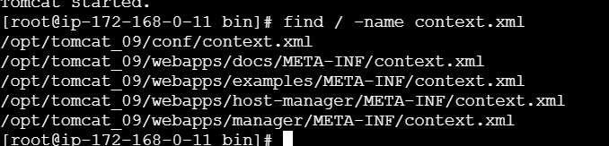
Then open the file and edit with the vi add <!-- & -->
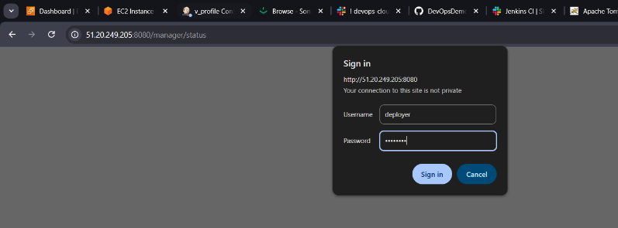
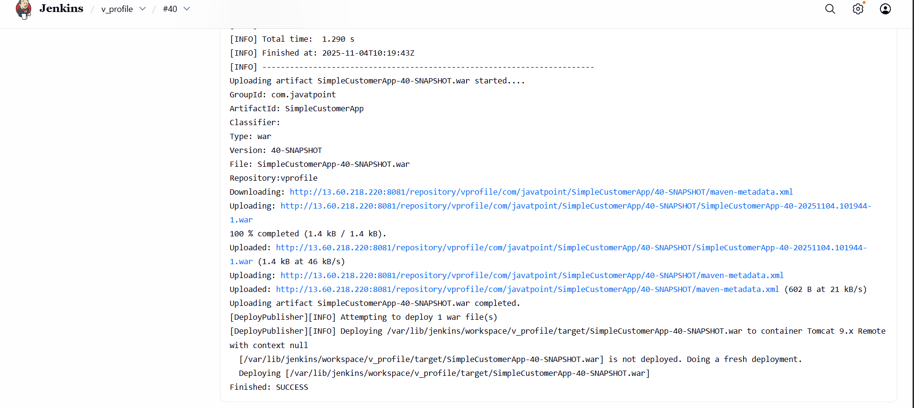

CREATE ONE PARALLEL STAGE PIPELINE JOB
- Parallel Stage: “Build” and “SonarQube Analysis” run simultaneously for faster pipeline execution
pipeline {
agent any

tools {
maven "MVN_HOME"
}

stages {
stage('Checkout') {
steps {
git branch: 'main',
url: 'https://github.com/pmohd6065-ux/hiring-app.git'
}
}

stage('Build & SonarQube (Parallel)') {
parallel {
stage('Build') {
steps {
sh 'mvn clean install -f pom.xml'
}
}

stage('SonarQube Analysis') {
steps {
withSonarQubeEnv('SonarQube') {
sh 'mvn sonar:sonar'
}
}
}
}
}

stage('Upload to Nexus') {
steps {
script {
nexusArtifactUploader(
artifacts: [[
artifactId: 'hiring',
classifier: '',
file: "target/hiring.war",
type: 'war'
]],
credentialsId: 'nexus',
groupId: 'in.javahome',
nexusUrl: '16.16.25.136:8081',
nexusVersion: 'nexus3',
protocol: 'http',
repository: 'hiring-app',
version: "3.0-SNAPSHOT"
)
}
}
}

stage('Deploy to Tomcat') {
steps {
script {
deploy adapters: [
tomcat9(
credentialsId: 'tomcat1',
path: '',
url: 'http://56.228.15.251:8080/manager/text'
)
],
war: '**/target/hiring.war'
}
}
}

stage('Slack Notification') {
steps {
slackSend(
channel: '#jenkins-integration',
message: "✅ Declarative pipeline for hiring app successfully completed"
)
}
}
}
}

